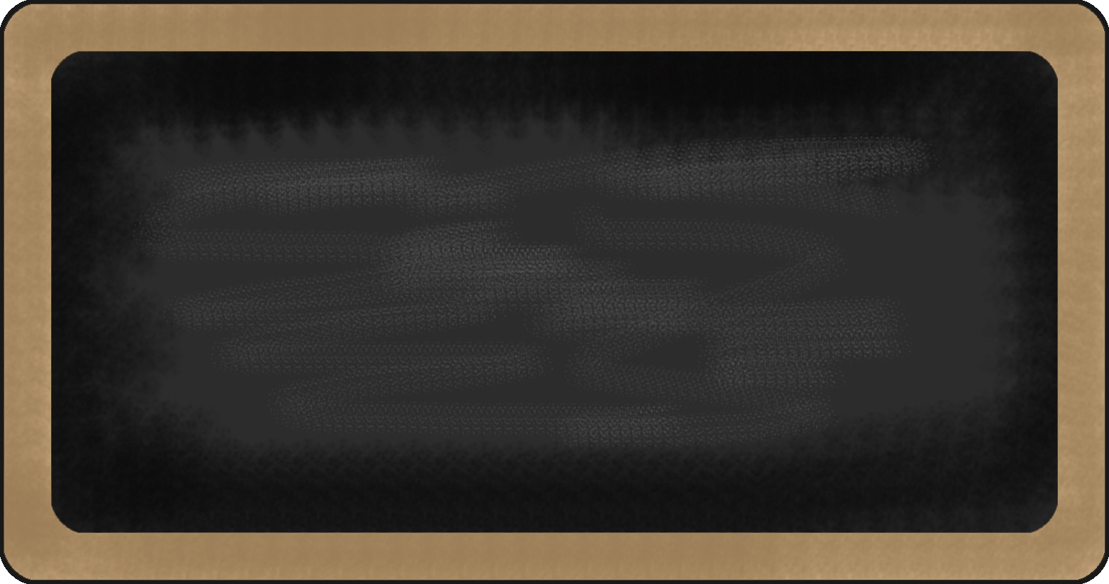
Sight Words
PreK review
- I
- the
- The
- my
- My
- like
- can
- a
- A
- see

Upcoming events

8/28/14 –12:45 dismissal
8/29/14 – Full day (3:00)
9/1/14 – No School-Labor Day
9/ /14 – Open House
9/25/14 –No School- Rosh Hashanah

Notes from the teacher:
Please call or email with questions/concerns the first few weeks-I won’t be able to talk to you at the end of the day or I’m afraid someone will get lost.
Please sign out your child-be patient until I get to know you-safety first. ☺ Thanks!!!

Happy Birthday to:

What We are learning this week:

reading | Writing | Word | Math | Science | Social studies
- We will be reviewing letters  - Recognizing our names. | - Writing names and letters  - drawing pictures | - Names of friends | - Number names  - Routines | - 5 Senses | - Routines and rules  - Be kind, share and  wait. ☺

Contact Information Mrs. McGuirk (203-576-7303 email: gmcguirk@bridgeportedu.net http://bridgeport.ct.schoolwebpages.com/education/staff/staff.php?sectionid=6560&

