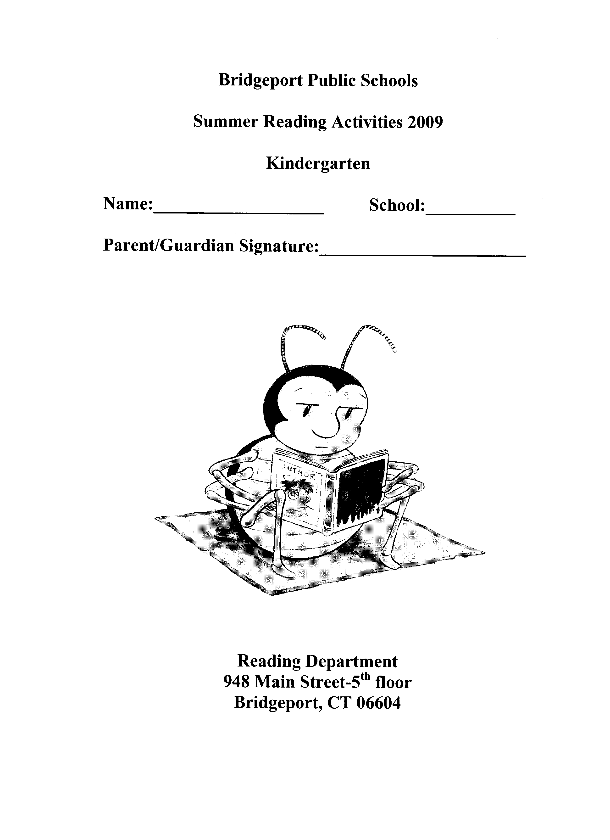

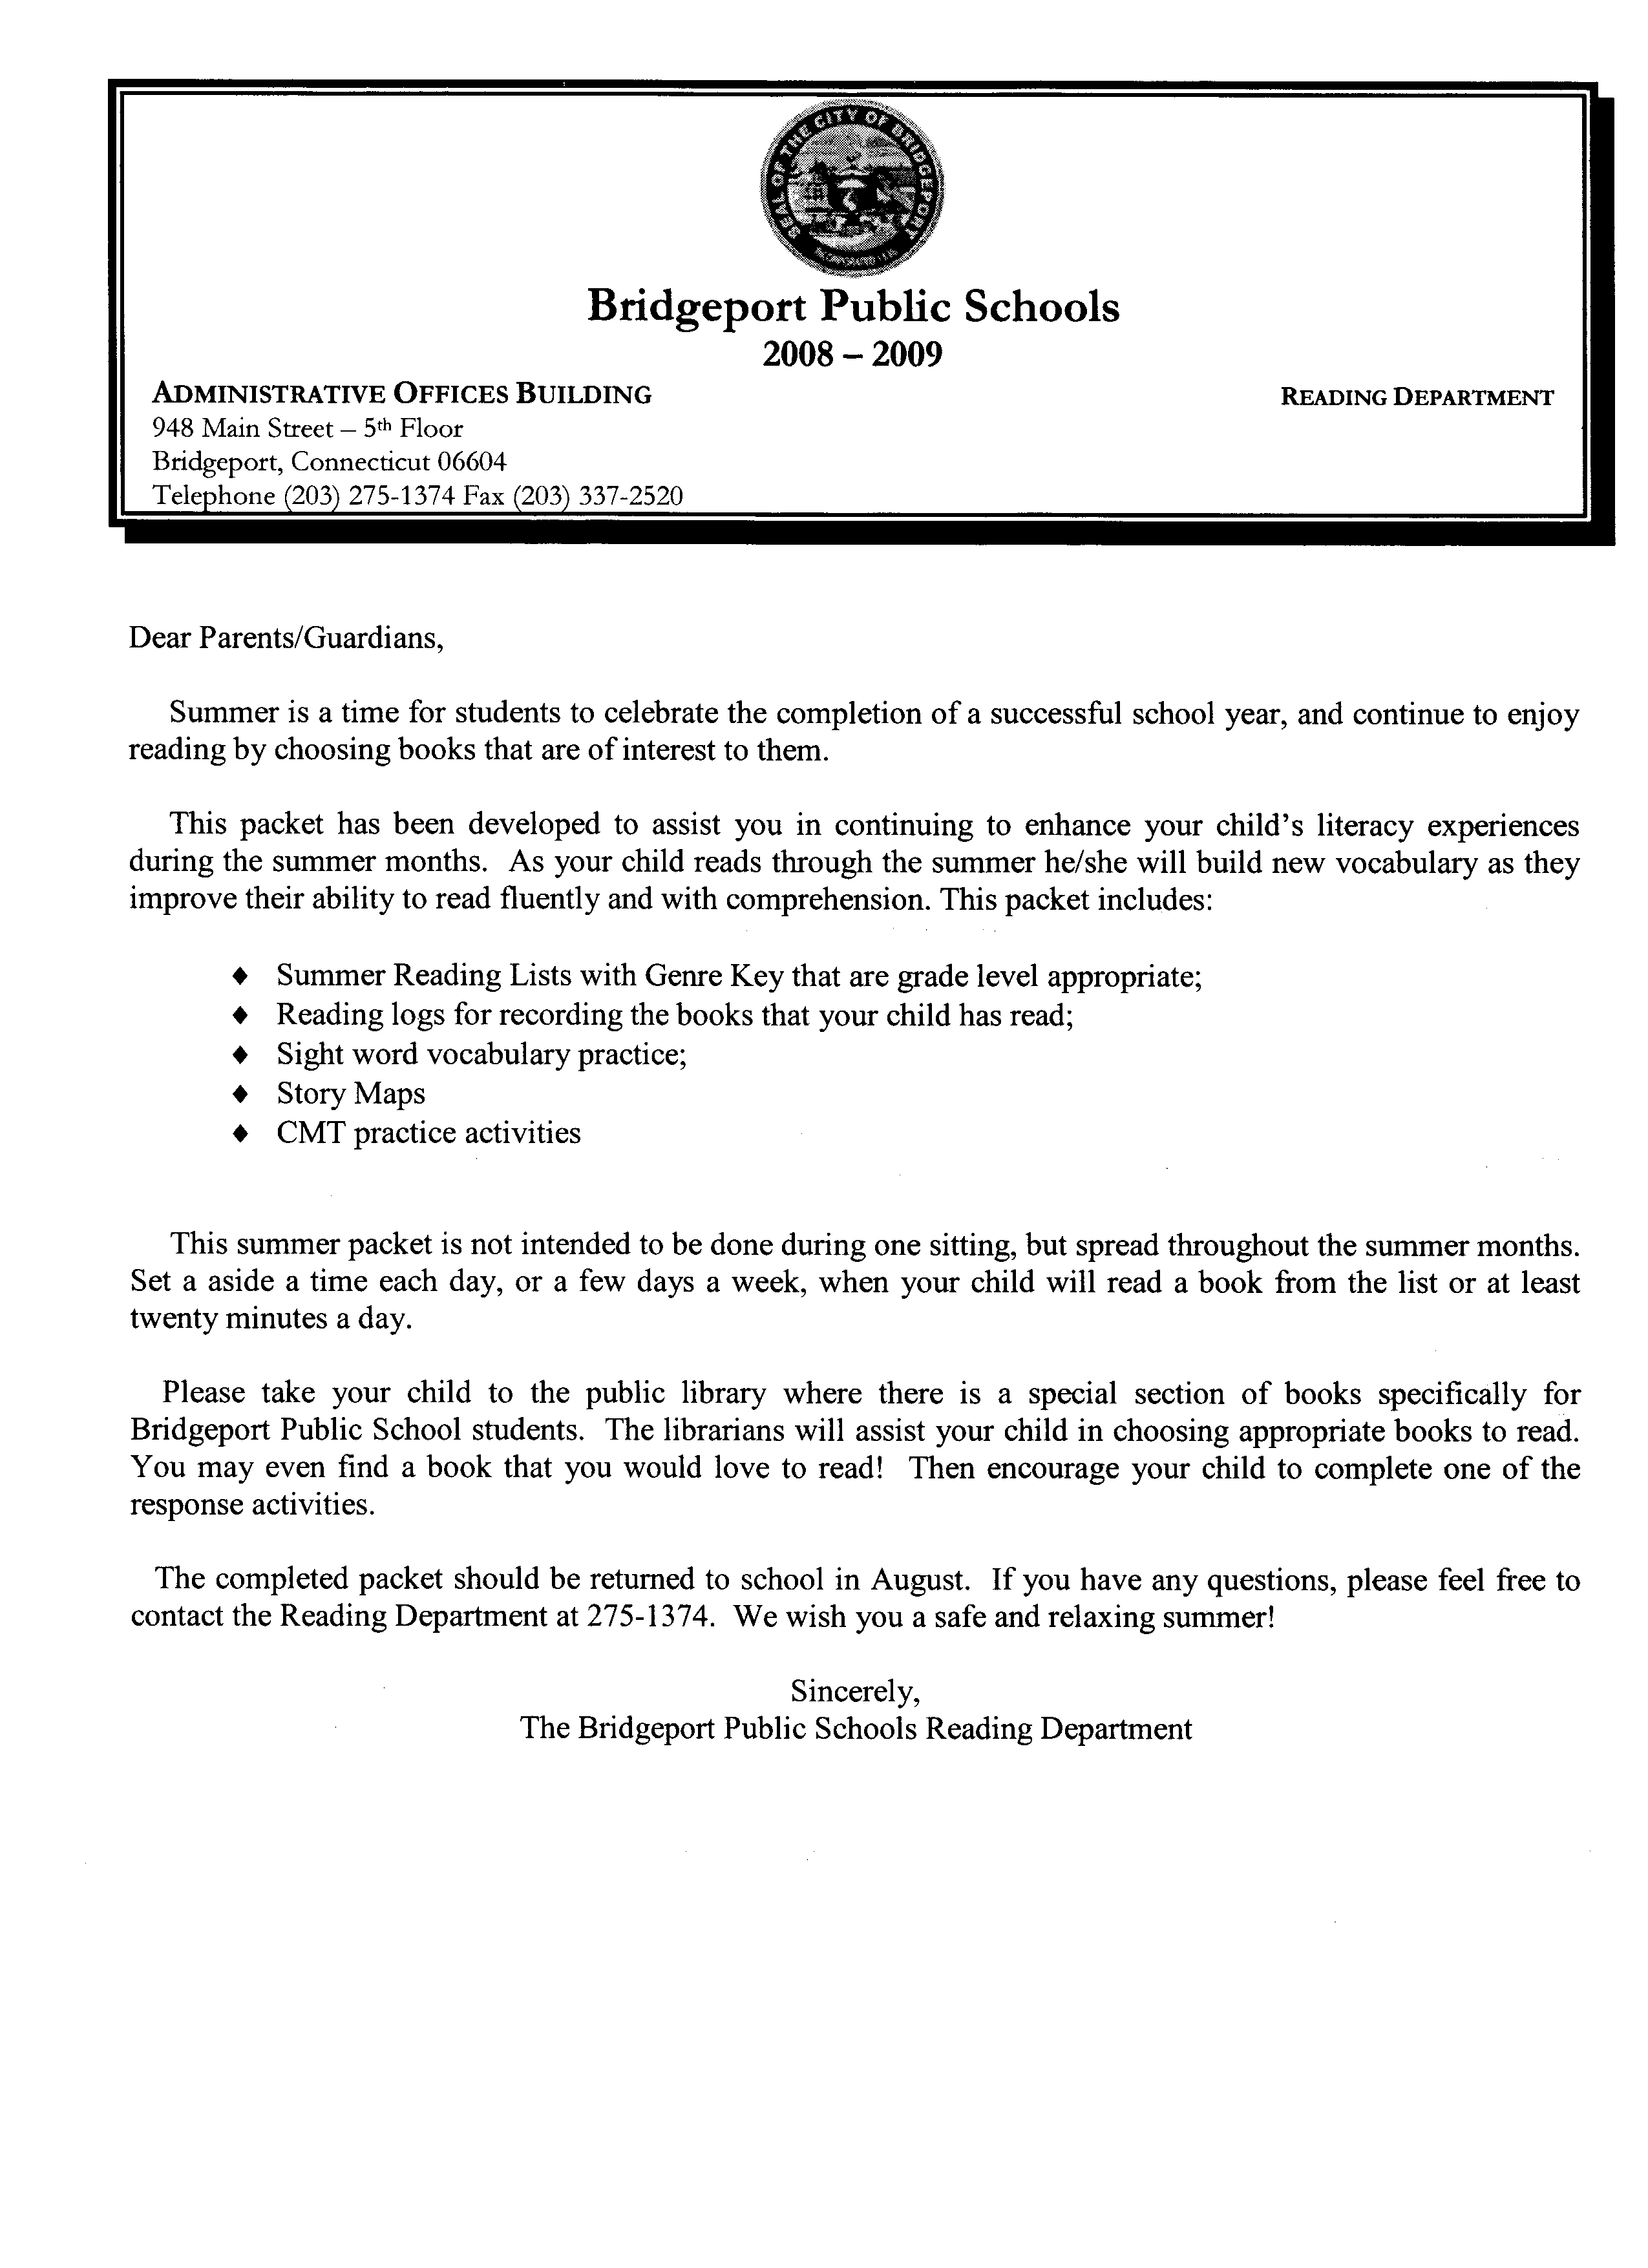

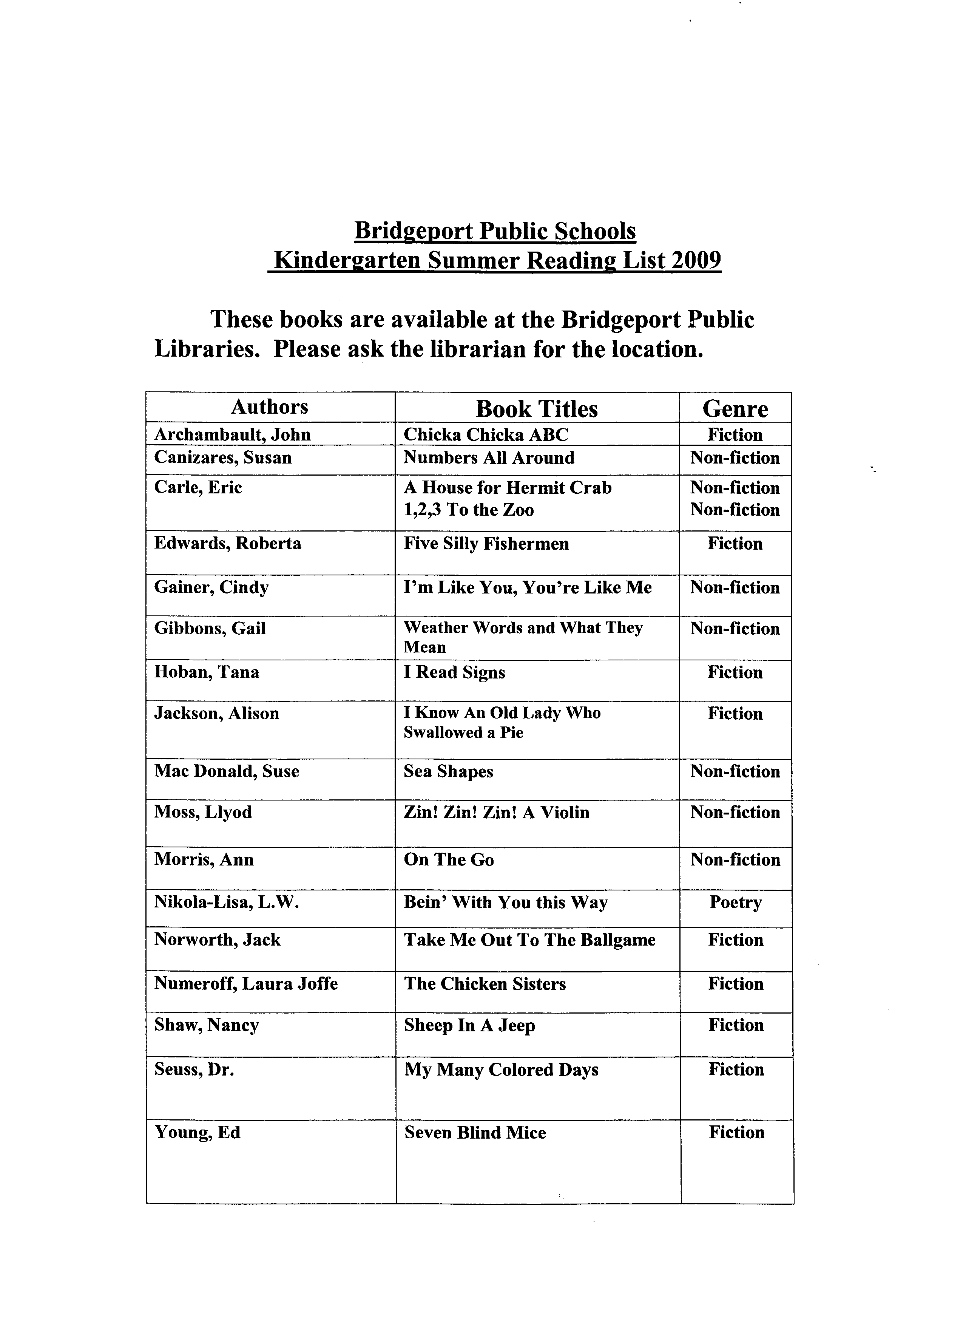

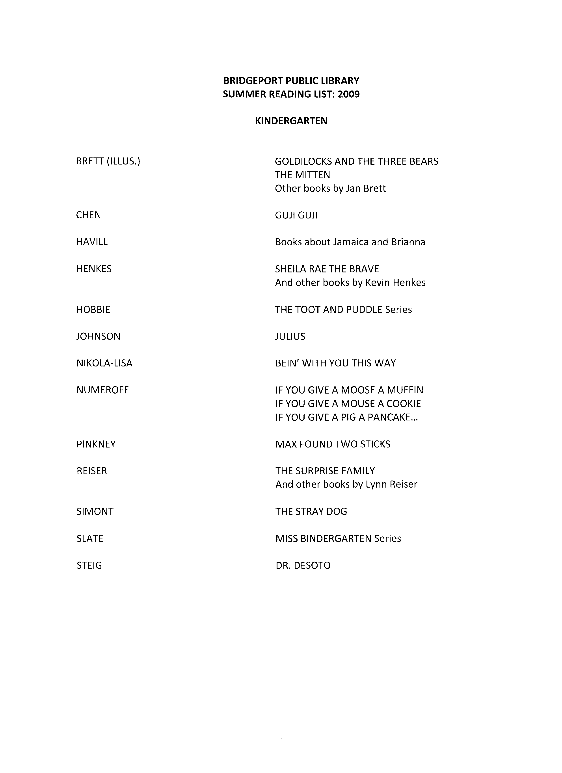

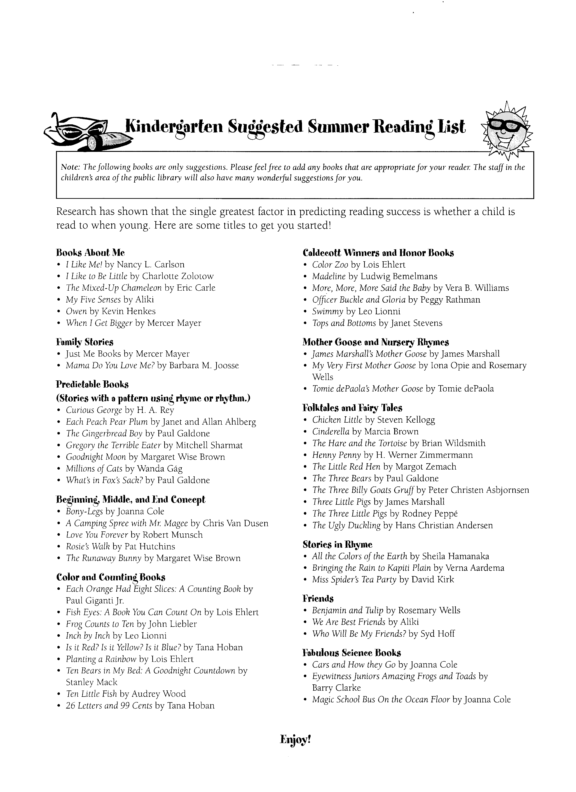

Bridgeport Public Libraries

Current Children’s Magazines

These magazines are available at the libraries.

American Girl (ages 8-11)
Appleseeds (ages 8-11)
Boy’s Life (ages 11 and up)
Cobblestone (ages 9-14)
Cousteau Kids (ages 8-12)
Cricket (ages 9-14)
Faces (ages 9-14)
Highlights for Children (ages 3-8)
Hopscotch for Girls (ages 6-12)
Humpty Dumpty (ages 4-6)
National Geographic World/Kids (ages 6-14)
New Moon (for girls ages 8-14)
Ranger Rick (ages 6-12)
Sports Illustrated for Kids (ages 8 and up)
Your Big Backyard (ages 3-7)

