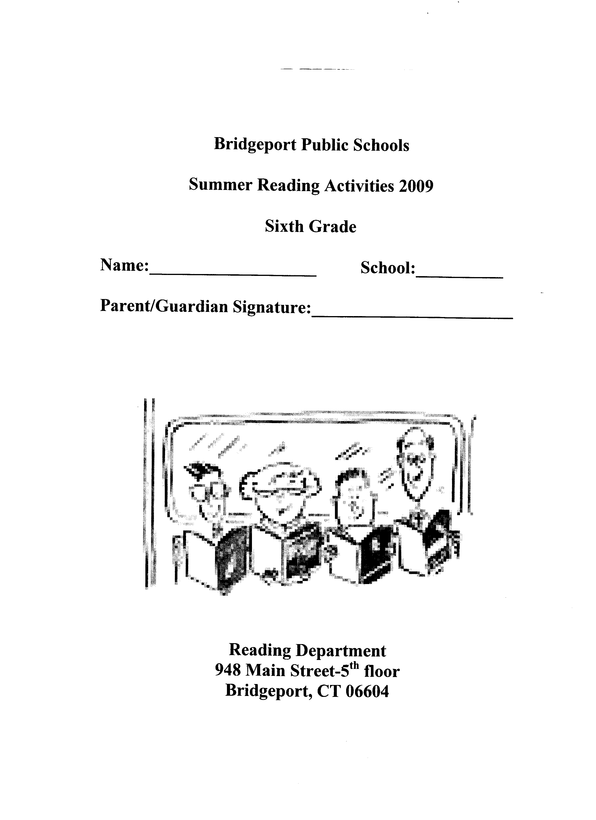

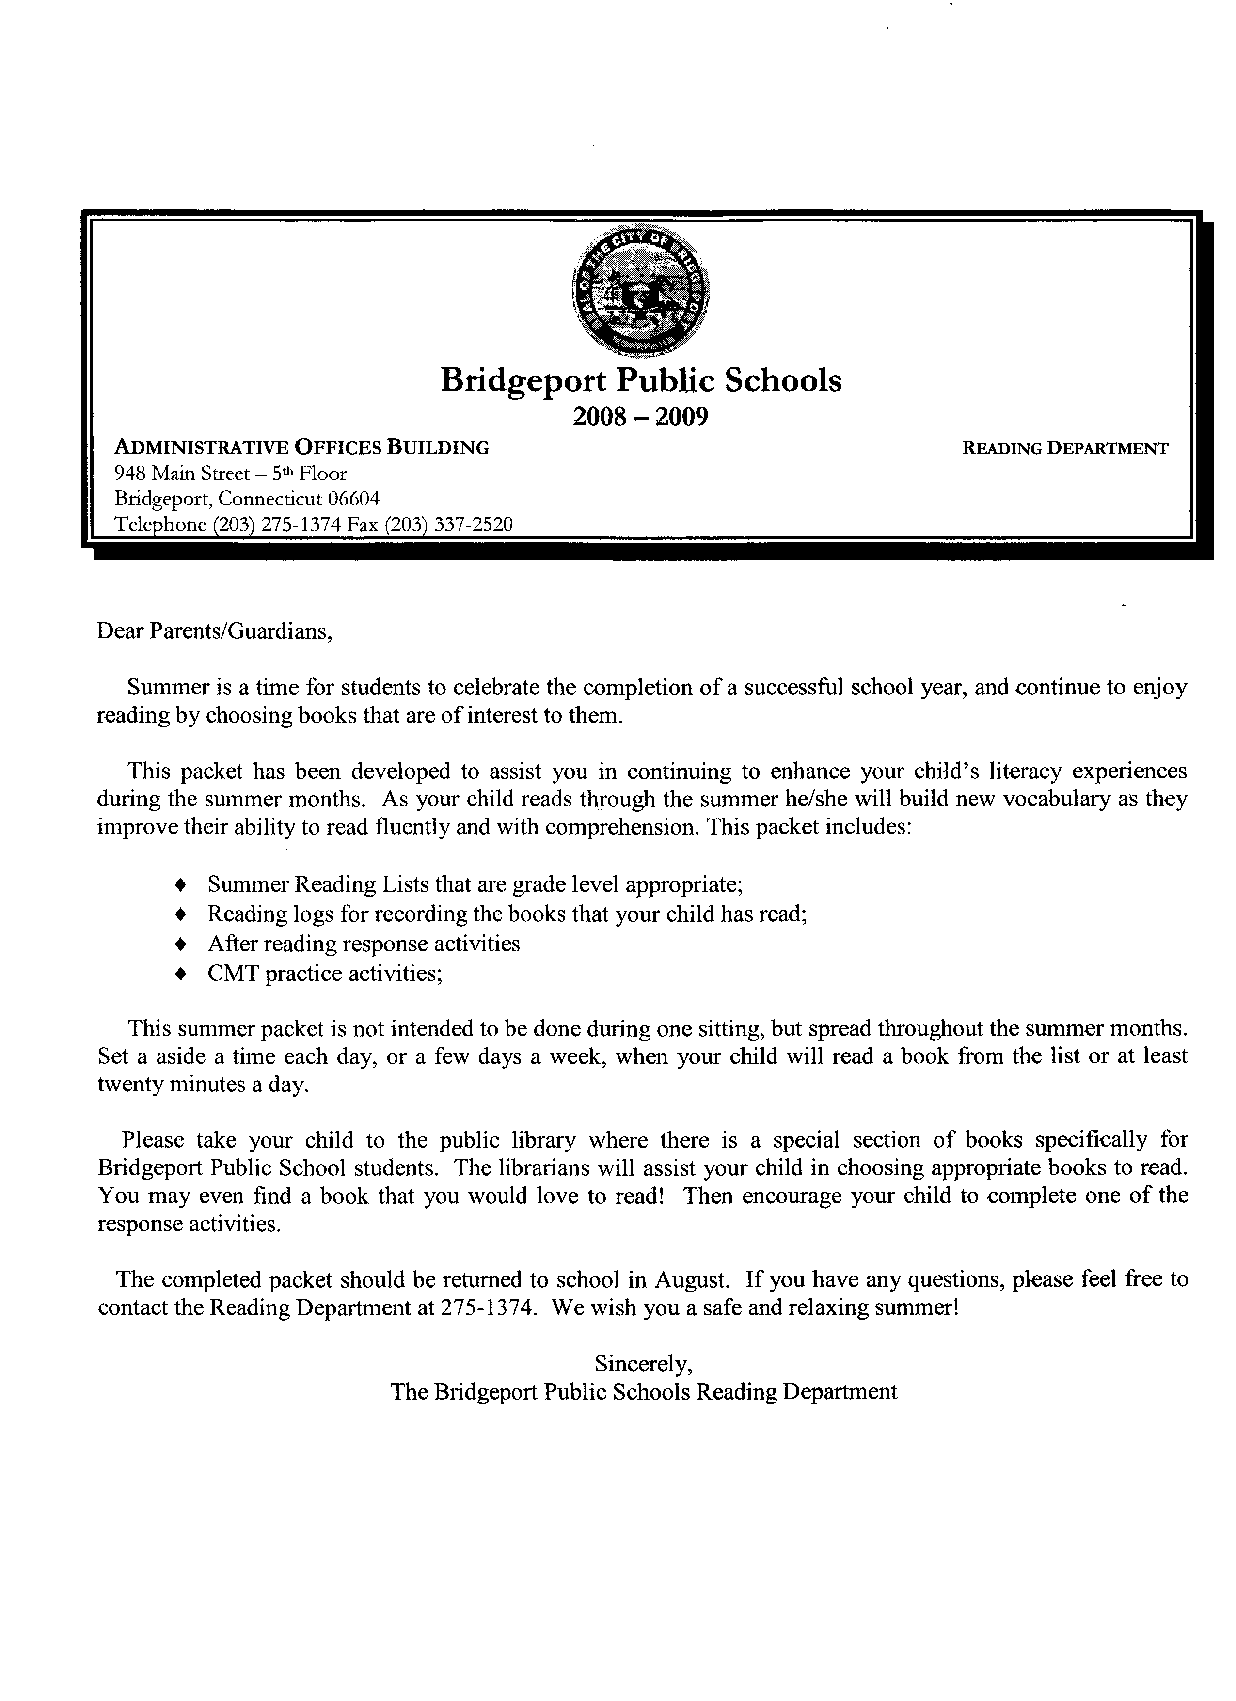

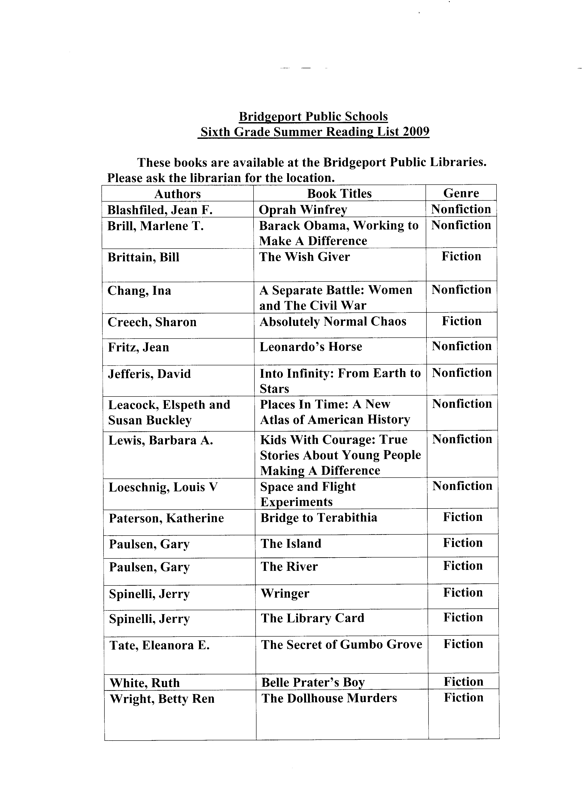

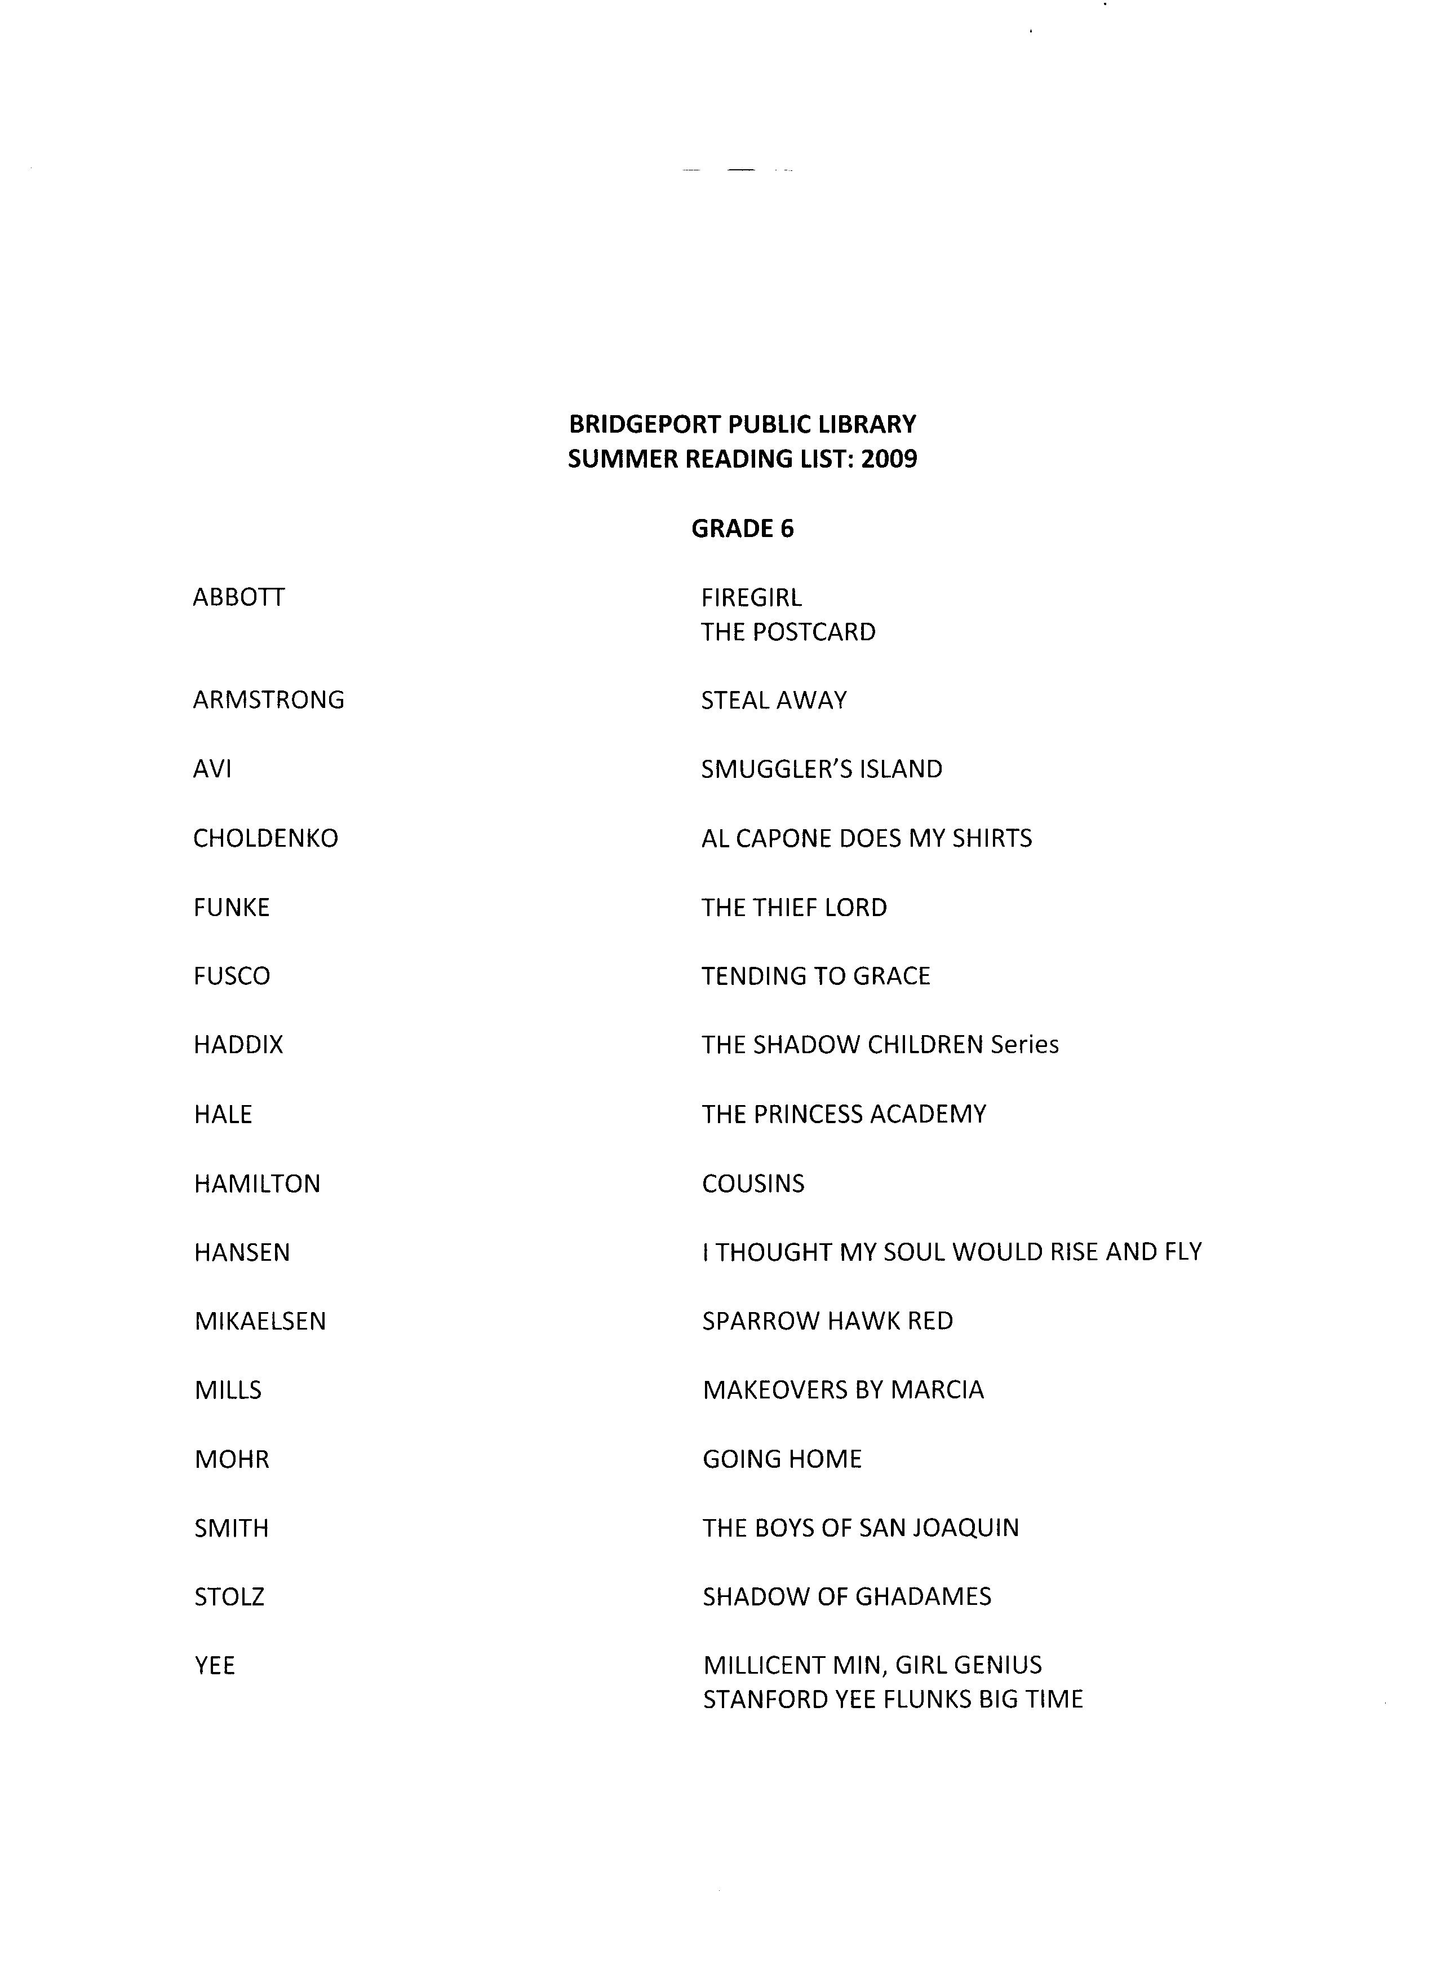

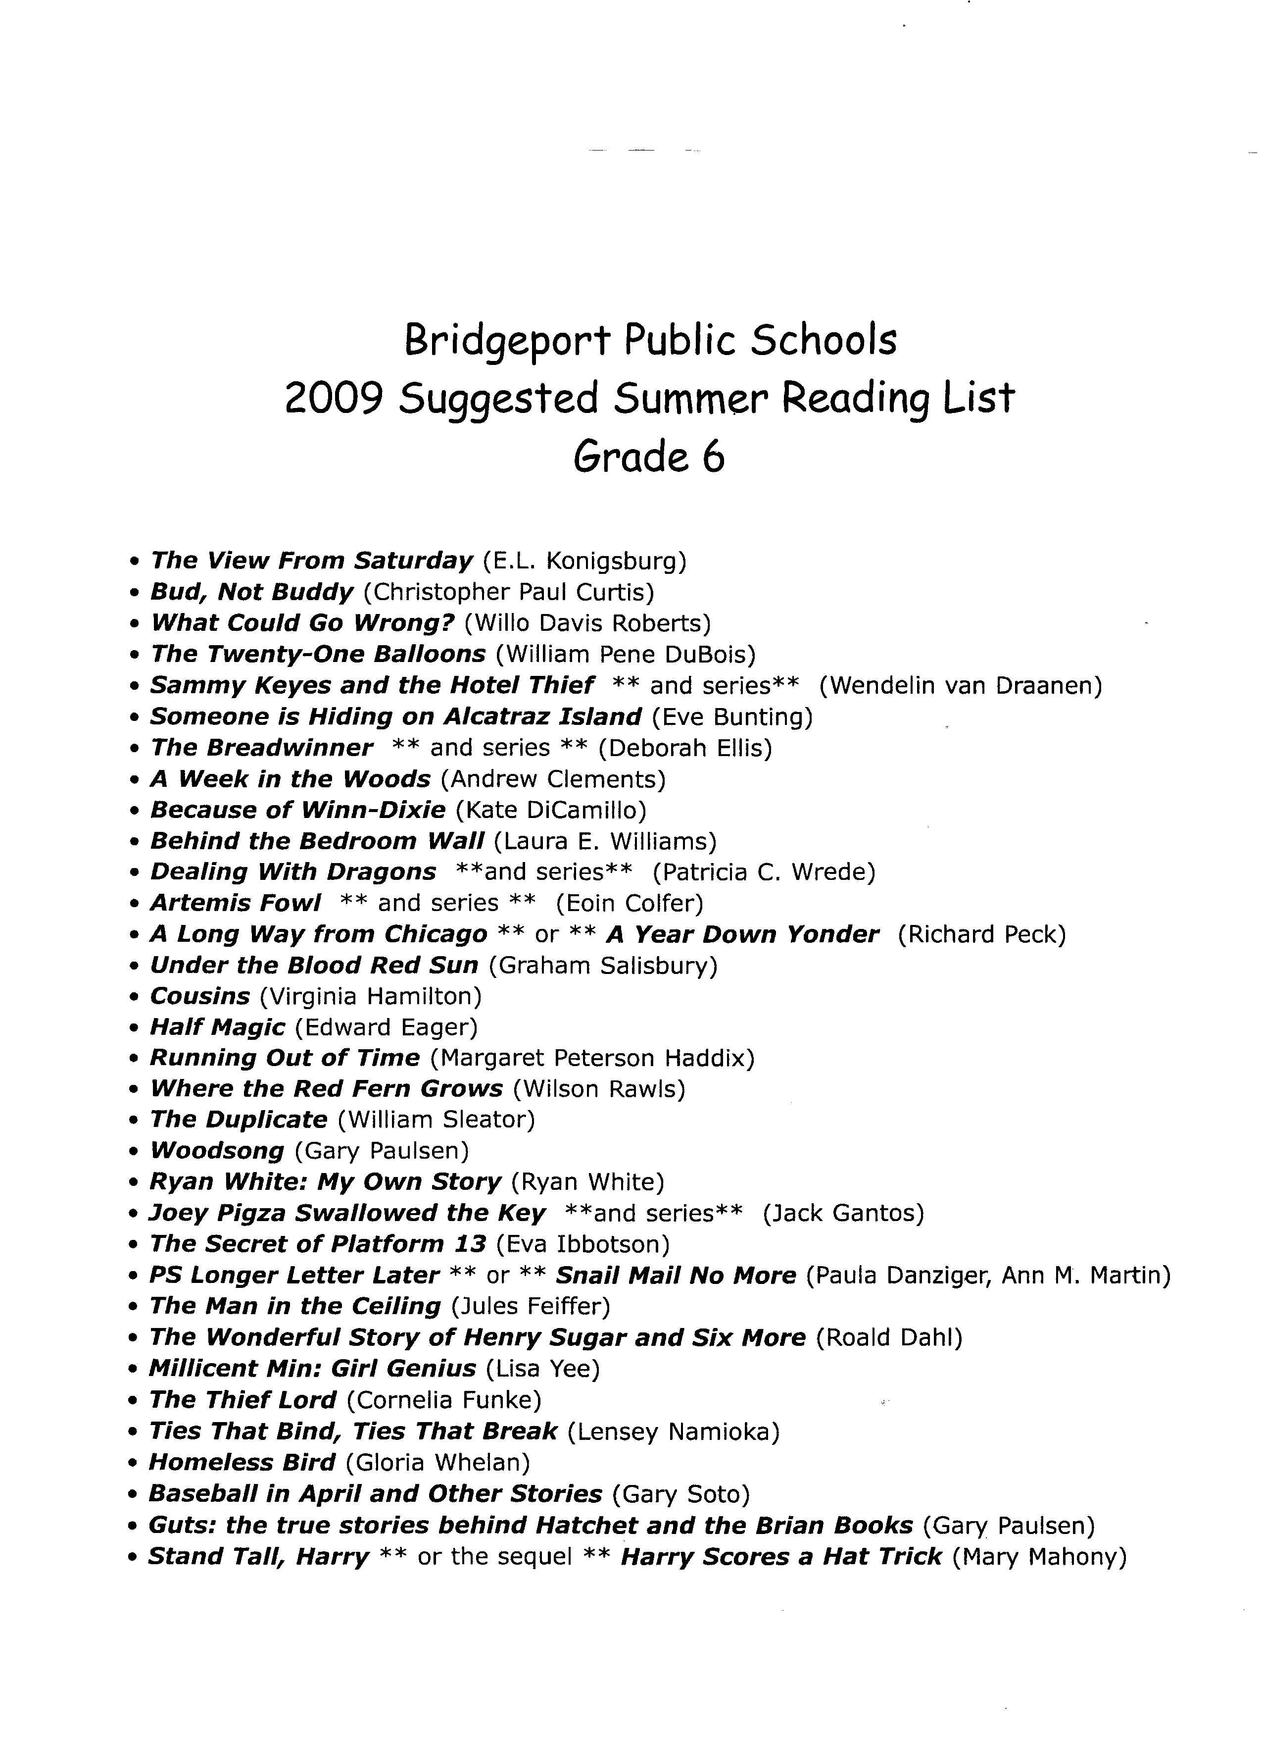

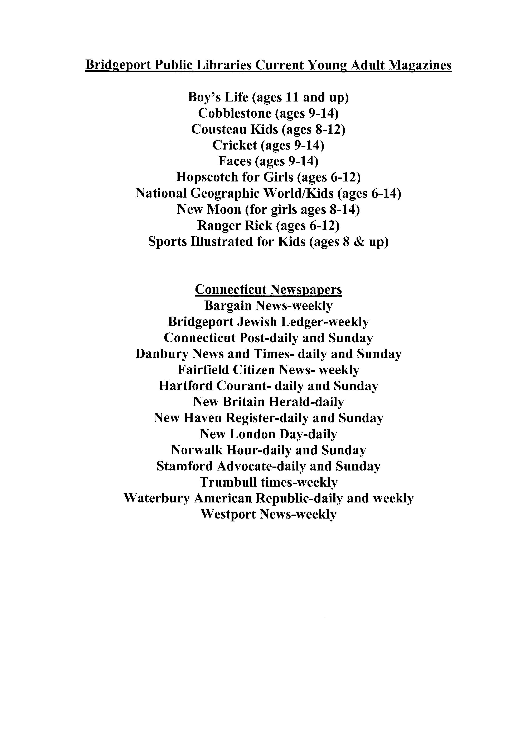

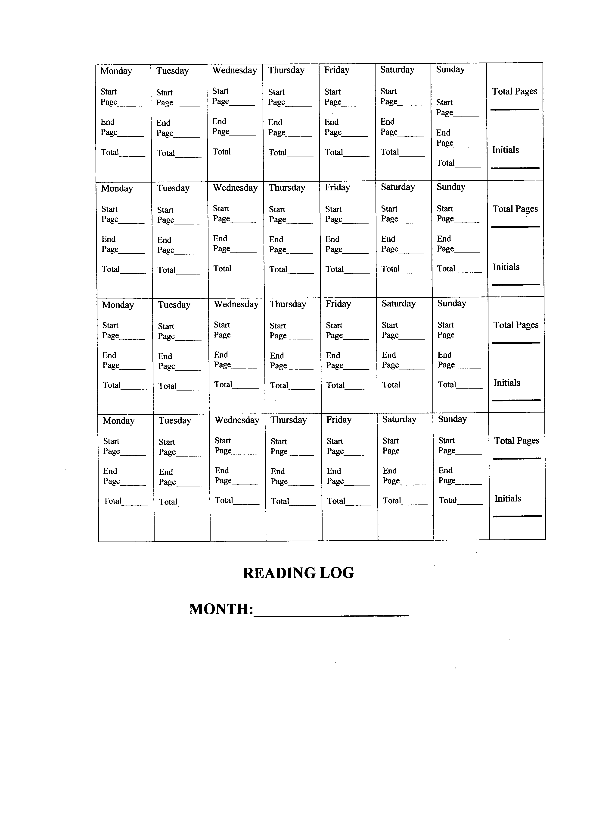

Summer Reading Response

Name:

Title of Book:

Author of Book:

Genre of Book:
(ex. Mystery, fantasy; adventure; contemporary fiction; historical fiction; etc.)

- Why did you select this book and what were your expectations?

____________________________________________________________________________________________________________________________________________________________________________________________________________________________________________________________________________________________________________________________________________________________________________________________________________________________________________________________________________________________________________________________________________________________________________________________________________________________________________________________________________________________________________________________________

- Explain how your expectations were realized or not realized.
_____________________________________________________________________________________________________________________________________________________________________________________________________________________________________________________________________________________________________________________________________________________________________________________________________________________________________________________________________________________________________________________________________________________________________

- How does this book relate to other books you have read?

__________________________________________________________________________________________________________________________________________________________________________________________________________________________________________________________________________________________________________________________________________________________________________________________________________________________________________________________________________________________________________________________________________________________________________________________________________________________________

- How does this book relate to personal knowledge or experience?
______________________________________________________________________________________________________________________________________________________________________________________________________________________________________________________________________________________________________________________________________________________________________________________________________________________________________________________________________________________________________________________________________________________________________________________________________________

- Did this book change any of your opinions or thoughts?

__________________________________________________________________________________________________________________________________________________________________________________________________________________________________________________________________________________________________________________________________________________________________________________________________________________________________________________________________________________________________________________________________________________________________________________________________________________________________
- I recommend this book to other readers who……
____________________________________________________________________________________________________________________________________________________________________________________________________________________________________________________________________________________________________________________________________________________________________________________________________________________________________________________________________________________________________________________________________________________________________________________________________________________________________________________________________________________________________________________________________________________________

- How many stars would you give this book? (1-5, with 5 being the highest)= __________________

1=This was the worst book I ever read.
5=I absolutely loved this book.

Summer Reading Response

Name:

Title of the book:

Author of the book:

Genre of the book:
(ex. Mystery; fantasy; adventure; contemporary fiction; historical fiction; etc.)

- Why did you select this book and what were your expectations?
____________________________________________________________________________________________________________________________________________________________________________________________________________________________________________________________________________________________________________________________________________________________________________________________________________________________________________________________________________________________________________________________________________________________________________________________________________________________________________________________________________________________________________________________________

- Explain how your expectations were realized or not realized.
_________________________________________________________________________________________________________________________________________________________________________________________________________________________________________________________________________________________________________________________________________________________________________________________________________________________________________________________________________________________________________________________________________________________________________________________________________________________________________________________________________

- How does this book relate to other books you have read?

__________________________________________________________________________________________________________________________________________________________________________________________________________________________________________________________________________________________________________________________________________________________________________________________________________________________________________________________________________________________________________________________________________________________________________________________________________________________________

- How does this book relate to personal knowledge or experience?
______________________________________________________________________________________________________________________________________________________________________________________________________________________________________________________________________________________________________________________________________________________________________________________________________________________________________________________________________________________________________________________________________________________________________________________________________________

- Did this book change any of your opinions or thoughts?

__________________________________________________________________________________________________________________________________________________________________________________________________________________________________________________________________________________________________________________________________________________________________________________________________________________________________________________________________________________________________________________________________________________________________________________________________________________________________

- commend this book to other readers who……
____________________________________________________________________________________________________________________________________________________________________________________________________________________________________________________________________________________________________________________________________________________________________________________________________________________________________________________________________________________________________________________________________________________________________________________________________________________________________________________________________________________________________________________________________________________________

- How many stars would you give this book? (1-5, with 5 being the highest)= __________________

1=This was the worst book I ever read.
5=I absolutely loved this book.

