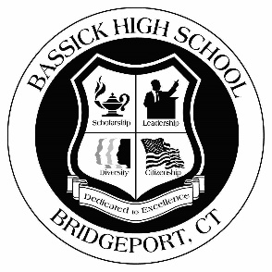

**Bassick High School Student Council**

*The Bassick High School community believes that all stakeholders should be engaged in meaningful ways in promoting a positive culture and climate for learning within the school. As such, the establishment of a representative Student Council will ensure that the student body as a whole participates actively in school governance and decision making.*

Criteria: Members of the student council should be student-leaders. As such, it is expected that they provide an example for their peers. In order to ensure that student council members are responsible members of the school community, candidates for student council should meet the following minimum criteria:

* Cumulative G.P.A. of 2.5 or greater
* Exceptional school attendance record
* Recognized leadership from peers (demonstrated by nomination)
* Recognized leadership ability by staff (demonstrated by written recommendation)

While not required, exceptionally strong candidates may demonstrate leadership ability through one or more of the following:

* Participation in sports, clubs, or other extracurricular activities
* Participation in the community through civic involvement (community service activity, church activity, volunteer activity)

Structure: As a representative body, the Student Council, working with and through the Faculty Advisor(s) will identify and propose solutions to issues of interest among the student body as a whole. To ensure appropriate representation, the Bassick High School Student Council will consist of the following members:

* (2) representatives from 9th Grade – one from each team
* (2) representatives from 10th Grade – one from each team
* (2) representatives from 11th Grade – chosen by nomination / election
* (2) representatives from 12th Grade – chosen by nomination / election
* A Student Council President – 12th grade, chosen by election
* Three Student Council Officers – Vice President, Secretary, Treasurer – 11th or 12th grade students, chosen by election

Function: The Student Council will meet regularly, as a group, in coordination with the Faculty Advisor. The Council will identify significant issues of interest to the student body as a whole. The council will discuss the identified issues and develop proposed solutions for presentation to the Principal, including Pro’s and Con’s for the proposed solution. The Student Council Officers will present issues, and/or provide progress updates, to the Principal, at regularly scheduled meetings. The Student Council Officers will then inform the members of the Student Council, who will communicate to the student body as a whole.